transPLANT milestone report
MS12 (work package 5): DAS servers provided for sequence and annotation for 10 reference genomes
The Distributed Annotation System (DAS; http://www.biodas.org) is a simple protocol for the publishing of reference entities and (positional or non-positional) annotation on those entities through the provision of a DAS server. The existence of DAS servers allows the development of DAS clients, integrative interfaces that selectively and dynamically integrate data from different sources. transPLANT partner EMBL-EBI has provides DAS through the Ensembl Plants interface: in the course of the first year of transPLANT, servers were provided for 10 additional genomes: Brassica rapa (turnip), Chlamydomonas reinhardtii (a red alga), Glycine max (soybean), Cyanidioschyzon merolae (a green alga), Oryza glaberina (African rice), Physcomitrella patens (a moss), Selaginella moellendorffii (spikemosse), Setaria italic (foxtail millet), Solanum lycopersicum (tomato), and Zea mays (maize). These new servers take the total number of DAS servers made available through Ensembl Plants to 19. We publish both the genomic sequence (allowing for its use as a reference by other annotation servers), and the annotation (genes, transcripts, translations) available within Ensembl Plants (as data on that reference) as DAS servers. Servers are also maintained for older versions of the genome, so that users can continue to visualise older annotation. Publishing annotation via DAS is based upon a common system for identification of reference sequence versions; allows for data sharing among consortium members and other sites and for visualisation in most commonly used genome browsers (for example, the Ensembl Genome Browser and Gbrowse are both DAS clients).
The availability of these DAS sources has been published at http://plants.ensembl.org/das/sources (see figure, below) and in the DAS registry (http://www.dasregistry.org/listServers.jsp).
Figure 1 Screenshot of DAS sources available in Ensembl Plants
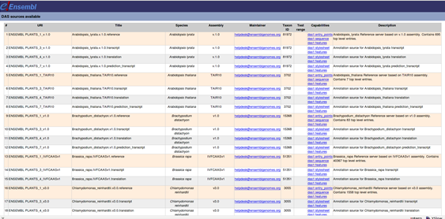
We will continue to publish additional DAS servers throughout the course of the project, while also developing new methods for users to integrate their data sets (which are increasingly based on new sequencing technologies, and consequently larger than traditional feature annotation) dynamically within Ensembl Plants and the other plant resources.

